HDBuddyPro
SC3040 | Advanced Software Engineering

Design Report on Software Maintainability
Version 1.0

By: Lim Wei Sheng, Lim Jun Jie, Loh Han Meng, Yun Kar Kit, Kee Yu Kai, Tai Yi Sheng Winston

Document Change Record
Revision | Description of Change | By | Date
0.10 | Initial Template | Lim Wei Sheng | 14/10/2026
0.20 | Add Design Strategies,  Architectural Design Patterns,  Software Configuration Management Tools | Lim Wei Sheng | 21/10/2026
1.00 | HDBuddyPro maintainability strategies, architecture and tooling revised; editorial cleanup. | Lim Wei Sheng | 26/10/2026

Contents
1. Design Strategies 3
1.1. The Planning Phase Before Development 3
1.2. The Process of Developing 3
1.3. Correction by Nature 4
1.3.1. Corrective Maintainability 4
1.3.2. Preventive Maintainability 4
1.4. Enhancement by Nature 4
1.4.1. Adaptive Maintainability 5
1.4.2. Perfective Maintainability 5
1.5. Maintainability Practices 5
2. Architectural Design Patterns 6
3. Software Configuration Management Tools 7
3.1. GitHub Projects 7
3.2. GitHub 8
3.3. Google Drive 8

1. Design Strategies

1.1. The Planning Phase Before Development
During the initial planning phase of HDBuddyPro, software maintainability was identified as an important consideration to support future enhancements, corrective maintenance, and changes to external data sources.

As HDBuddyPro integrates HDB resale transaction data and location-based information from external services such as data.gov.sg and OneMap, changes to data formats, API specifications, and available datasets are anticipated. Therefore, the system design should minimize dependencies between data retrieval, processing, and presentation components, allowing individual components to be updated without requiring extensive modifications to the overall application.

The proposed system architecture separates the React-based frontend from the Node.js/Express backend, with additional components responsible for data processing and AI chatbot functionality. This separation of concerns is intended to improve modularity, simplify debugging, and facilitate independent maintenance of different application components.

Future enhancements may include additional housing information, new filtering criteria, improvements to personalised ranking algorithms, and expanded data visualisations. By considering these potential changes during the planning phase, the development team aims to reduce the complexity and effort required for subsequent modifications while maintaining the reliability and consistency of the application.

1.2. The Process of Developing
The HDBuddyPro development plan uses a staged prototyping approach, with an initial demonstrable version followed by a more complete final deliverable. The team plans to build and refine features in manageable increments, including map-based flat filtering, resale information summaries, personalised rankings, regional statistics, and the AI chatbot. This approach allows integration issues and defects to be identified before the final handover.
To coordinate development, the team plans to use GitHub Projects and issues to record tasks, defects, and change requests. Proposed changes will be linked to relevant requirements, implemented through traceable branches or commits, reviewed by team members, and tested before inclusion in a release baseline. Keeping changes focused on individual features is intended to reduce unintended effects on unrelated functionality and support future maintenance.
Verification is planned throughout development, with checks against the software requirements and regression testing when functionality changes. Particular attention will be given to interactions between the proposed React frontend and Express backend, and to data quality and error handling for data.gov.sg and OneMap integrations. Test findings and outstanding issues should be documented for follow-up. These are planned practices; their completion and supporting test evidence must be recorded separately.

1.3. Correction by Nature
For HDBuddyPro, correction and prevention are considered together to keep the application reliable and maintainable as it evolves. Corrective maintenance addresses defects discovered during development and testing, while preventive maintenance aims to reduce the likelihood of similar issues arising in later changes. Particular attention is given to the accuracy of housing data, map-based searches, ranking results, external service integrations, and chatbot responses. The following subsections describe the team's intended approaches; completed activities and outcomes should be supported by project records.

1.3.1. Corrective Maintainability
Corrective maintenance focuses on identifying, diagnosing, and resolving defects reported through testing, quality reviews, or team feedback. In HDBuddyPro, potential faults include incorrect flat-filtering results, misplaced map markers, inaccurate proximity or ranking calculations, failures in data.gov.sg or OneMap integration, and chatbot responses inconsistent with the available housing data. Each defect should be recorded in a GitHub issue with reproduction steps, expected and actual results, priority, and an assigned owner. After making a correction, the team should perform relevant tests and regression checks to confirm that the defect is resolved without adversely affecting related features.

1.3.2. Preventive Maintainability
Preventive maintenance aims to reduce future defects and simplify subsequent changes to HDBuddyPro. The team plans to keep the user interface, backend services, data processing, and chatbot functions logically separated, with clear naming conventions and documentation of important interfaces. Focused changes should undergo peer review, particularly when external data formats or API behaviour may change. Where feasible, repeatable tests with representative data and regression checks should be used to identify unintended effects on flat filtering, map results, regional statistics, personalised ranking, and chatbot functions. These are intended maintainability practices and should be supported by review and test records as they are implemented.

1.4. Enhancement by Nature
Enhancement-oriented maintenance considers how HDBuddyPro may evolve after its initial prototype and final project delivery. Beyond fixing defects, the team plans to accommodate changes in external data sources and operating environments (adaptive maintenance) and improve existing features in response to user feedback and performance findings (perfective maintenance). The proposed approach focuses on controlling the impact of changes to map-based search, flat information, personalised ranking, regional statistics, and AI chatbot functionality. These are design intentions rather than claims that all enhancements have already been implemented.

1.4.1. Adaptive Maintainability
Adaptive maintainability concerns changes required when HDBuddyPro’s operating environment or external dependencies evolve. The application is planned to rely on government datasets and services such as data.gov.sg and OneMap, as well as an external AI API. Changes to API endpoints, request and response formats, authentication, dataset schemas, or library versions may require updates. To reduce the impact of such changes, the team intends to keep data retrieval and processing responsibilities separate from frontend presentation and to document important interfaces between components. When a dependency changes, the affected data handling, API interactions, and user-facing functions should be revalidated with representative test data before the updated release baseline is accepted.

1.4.2. Perfective Maintainability
Perfective maintainability involves refining existing software to improve usability, performance, and functionality without changing its core purpose. For HDBuddyPro, possible improvements include more intuitive flat-filtering and map navigation, clearer regional resale-price statistics, more efficient retrieval and display of results, refinements to personalised ranking criteria, and more useful chatbot responses. The team plans to assess suggested improvements against the agreed requirements and available development time, record approved changes through its GitHub workflow, and make enhancements in manageable increments. Relevant user journeys and regression tests should be rerun after each change, with the results and any known limitations documented for subsequent maintenance.

1.5. Maintainability Practices
To make HDBuddyPro easier to understand, troubleshoot and extend, the team intends to apply four maintainability practices across its source code and project documentation. Their use should be supported by code reviews, version history and other project records as development progresses.
- Readable Code — Use descriptive names and consistent coding conventions for the proposed React components, Express routes, data-processing functions and chatbot logic. Keep functions focused and document non-obvious calculations so another developer can locate, understand and safely modify the relevant behaviour.
- Version Control — Use Git and GitHub to track revisions to source code and project documents. Proposed changes should be linked to issues, implemented through traceable branches or commits, and reviewed before merging. Release tags or baselines should identify versions used for demonstrations and final submission.
- Standardized Documentation — Maintain consistent, updated requirements, design descriptions, API and data-source notes, change records and release information. Use clear version identifiers and cross-references between the Software Requirements Specification, GitHub issues and related documents to help team members understand the reason and impact of changes.
- Modularity — Keep the planned React frontend, Express backend, data-processing routines and AI chatbot integration in clearly defined components. Where practical, isolate external API access and data transformation from presentation so that changes to government data sources or individual features have a smaller impact on unrelated functionality.

2. Architectural Design Patterns

HDBuddyPro is planned around a modular, layered client–server architecture that separates the user interface, application services, and data or external-service integrations. The separation of concerns is used as the design rationale; a strict Model–View–Controller (MVC) implementation is not asserted without source-code verification. The architecture described here is based on the HDBuddyPro project and release plans; implementation details have not yet been verified against the application source code.
Presentation layer: The proposed React frontend, built with Vite, provides the user-facing functions, including flat search and filters, interactive map results, resale-flat summaries, regional statistics, personalised ranking displays, and an AI chatbot interface. Keeping presentation concerns separate is intended to make changes to layouts and user interactions easier to maintain.
Application layer: The proposed Node.js/Express backend handles application requests and coordinates backend functionality such as data retrieval, ranking-related processing and chatbot interactions. Clear interfaces between frontend requests and backend responses should allow changes to business logic without requiring unrelated user-interface changes.
Data and integration layer: The design references MongoDB for data storage, Pandas for data preparation, data.gov.sg and OneMap for external housing and location information, and the OpenAI API for chatbot capabilities. Isolating data-processing responsibilities and third-party service integrations is intended to reduce the effects of changing dataset schemas, API behavior or dependencies. The team should document and test component interfaces as the implementation is refined.

Figure 1 illustrates the proposed component-level architecture of HDBuddyPro:
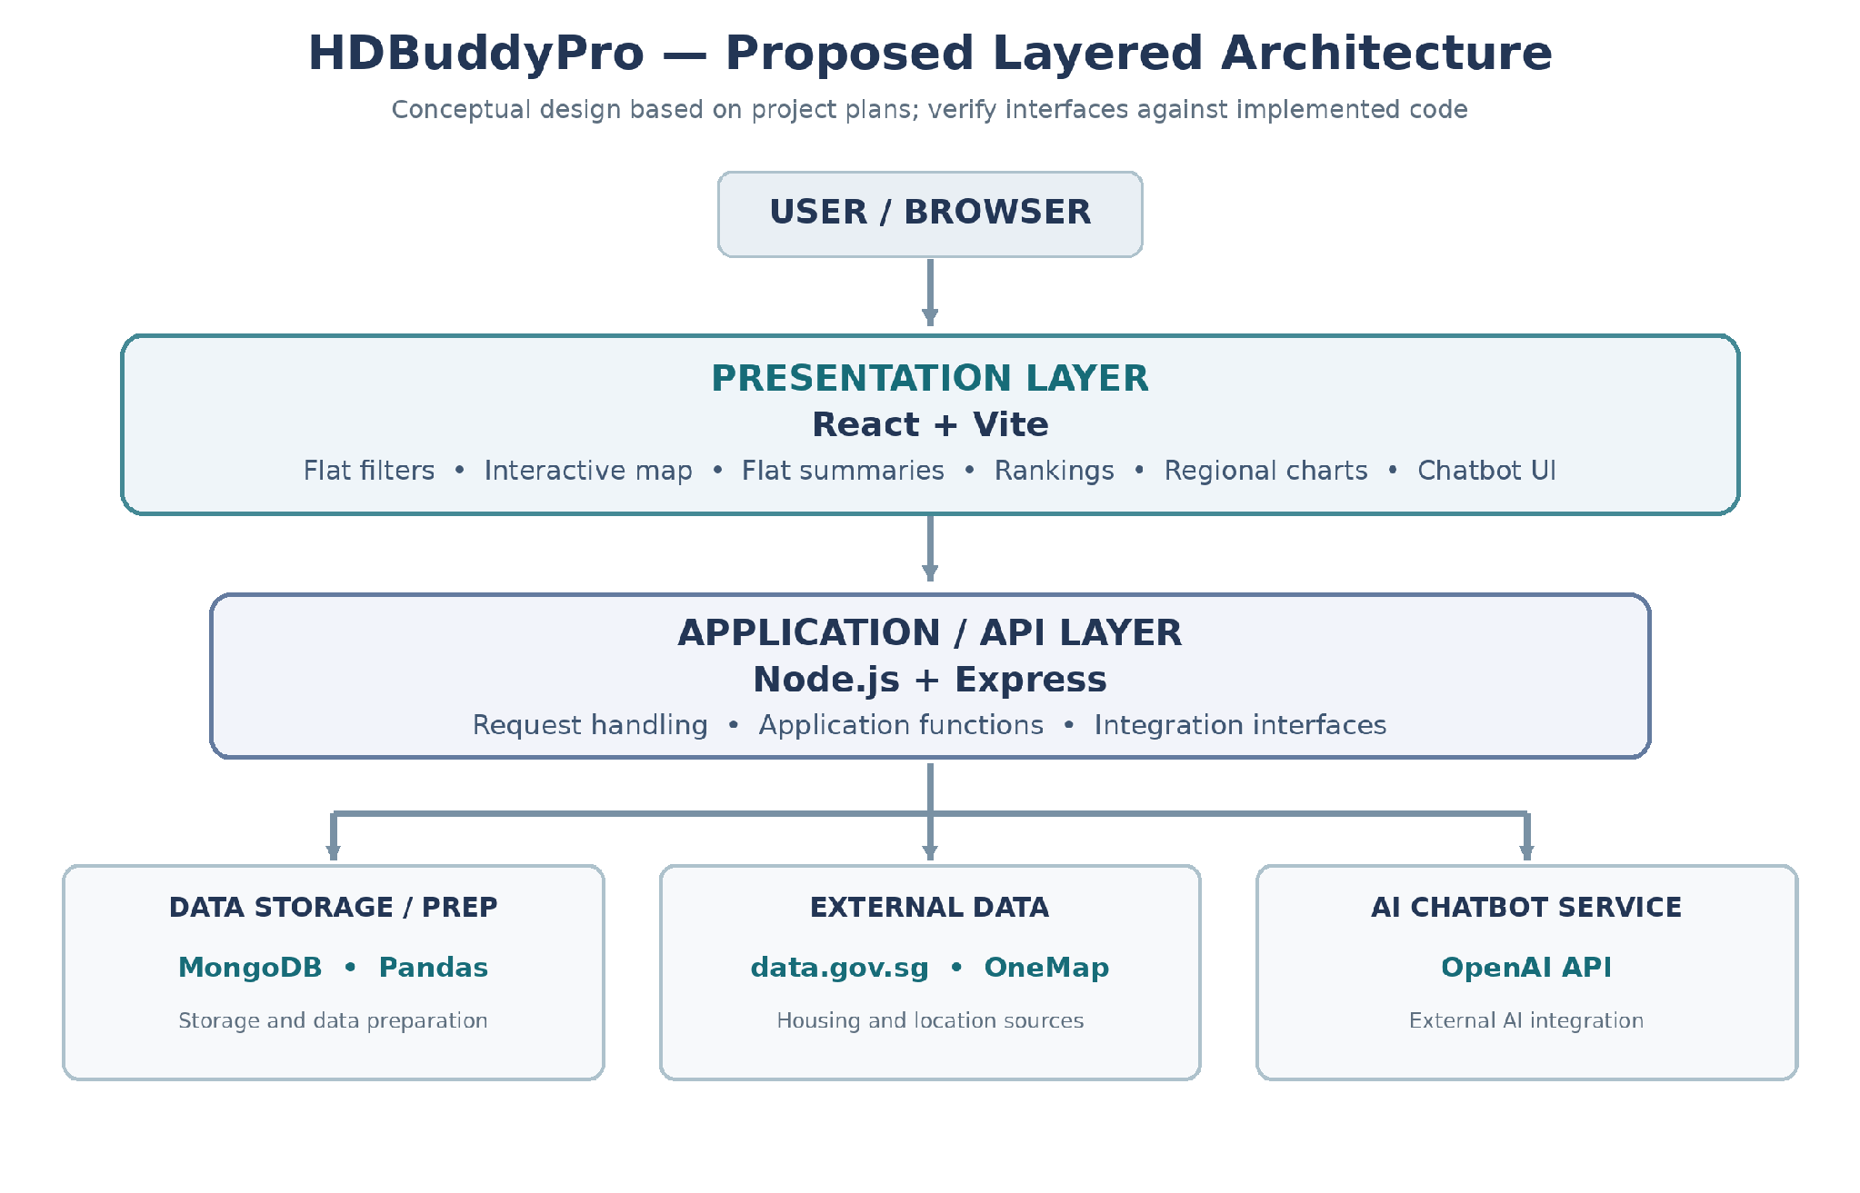

3. Software Configuration Management Tools

HDBuddyPro uses GitHub and Google Drive to coordinate configuration management, document collaboration and change tracking. The team aims to maintain traceability between work items, controlled documents, source code, reviews and release baselines, so that future maintainers can understand what changed, why it changed and which version was delivered. The tools and procedures below describe the documented workflow and intended controls; implementation evidence should be retained in the corresponding project records.

3.1. GitHub Projects
The team uses a shared GitHub Projects board to organize project tasks and proposed changes. As defined in the Change Management Plan, change requests should be recorded with an identifier, affected feature or requirement, rationale, priority, assignee, decision and current status. Where applicable, a work item should link to the related GitHub issue, pull request, test evidence and target release. This supports maintainability by preserving the context of technical decisions and enabling the team to follow outstanding defects or enhancements through review, testing and closure.

3.2. GitHub
GitHub provides the Git repository used to version the project deliverables and is the planned platform for managing application source code. Git commits provide a record of revisions, while branches and pull requests can support the team’s proposed change-review process. To keep modifications traceable, the team intends to reference relevant tasks or change requests in commits and reviews, check changes before merging, and use version identifiers or release tags to identify approved baselines. The exact branching, review and release procedures should remain consistent with the Software Configuration Management Plan and be supported by repository history.

3.3. Google Drive
The team’s shared Google Drive folder supports collaborative preparation and review of HDBuddyPro documents, including the maintainability report, configuration management plan, change management plan, release plan and backlog. Working files can be revised and shared among team members before they are approved for a release. Because a collaboratively edited draft is not automatically a controlled baseline, finalized versions should use consistent document identifiers and revision records, with approved deliverables checked into the designated GitHub repository where required. This reduces confusion over document versions during maintenance and handover.

